Ref: MIA/2016-17/Ex. Cir. /05 Date: 30.05.2017

To,

All Executive Members,

SUB: - EXECUTIVE COMMITTEE MEETING
Dear Member,

The 5th executive committee meeting of the Association will be held on the date, time and venue as under: -

DAY & DATE : SATURDAY, 03 JUNE, 2017
TIME : 5.30 PM
VENUE : MARUDHARA INDUSTRIES ASSOCIATION
MIA HOUSE, BASNI II PHASE, JODHPUR

The agenda for the meeting will be as under: -

- To confirm minutes of last Executive Committee Meeting.
- To discuss about MIA website
- To confirm new membership
- To appoint Election Officer in terms of article 14.1 of the constitution for the year 2017-18
- Any other matter with the permission of the chair.

All the executive committee members are requested to kindly attend the meeting on scheduled time.

Thanking you,

Yours truly,
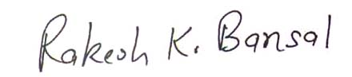

(RAKESH KR. BANSAL)
Hony. Secretary

